Sexual Abuse and Exploitation Code of Conduct

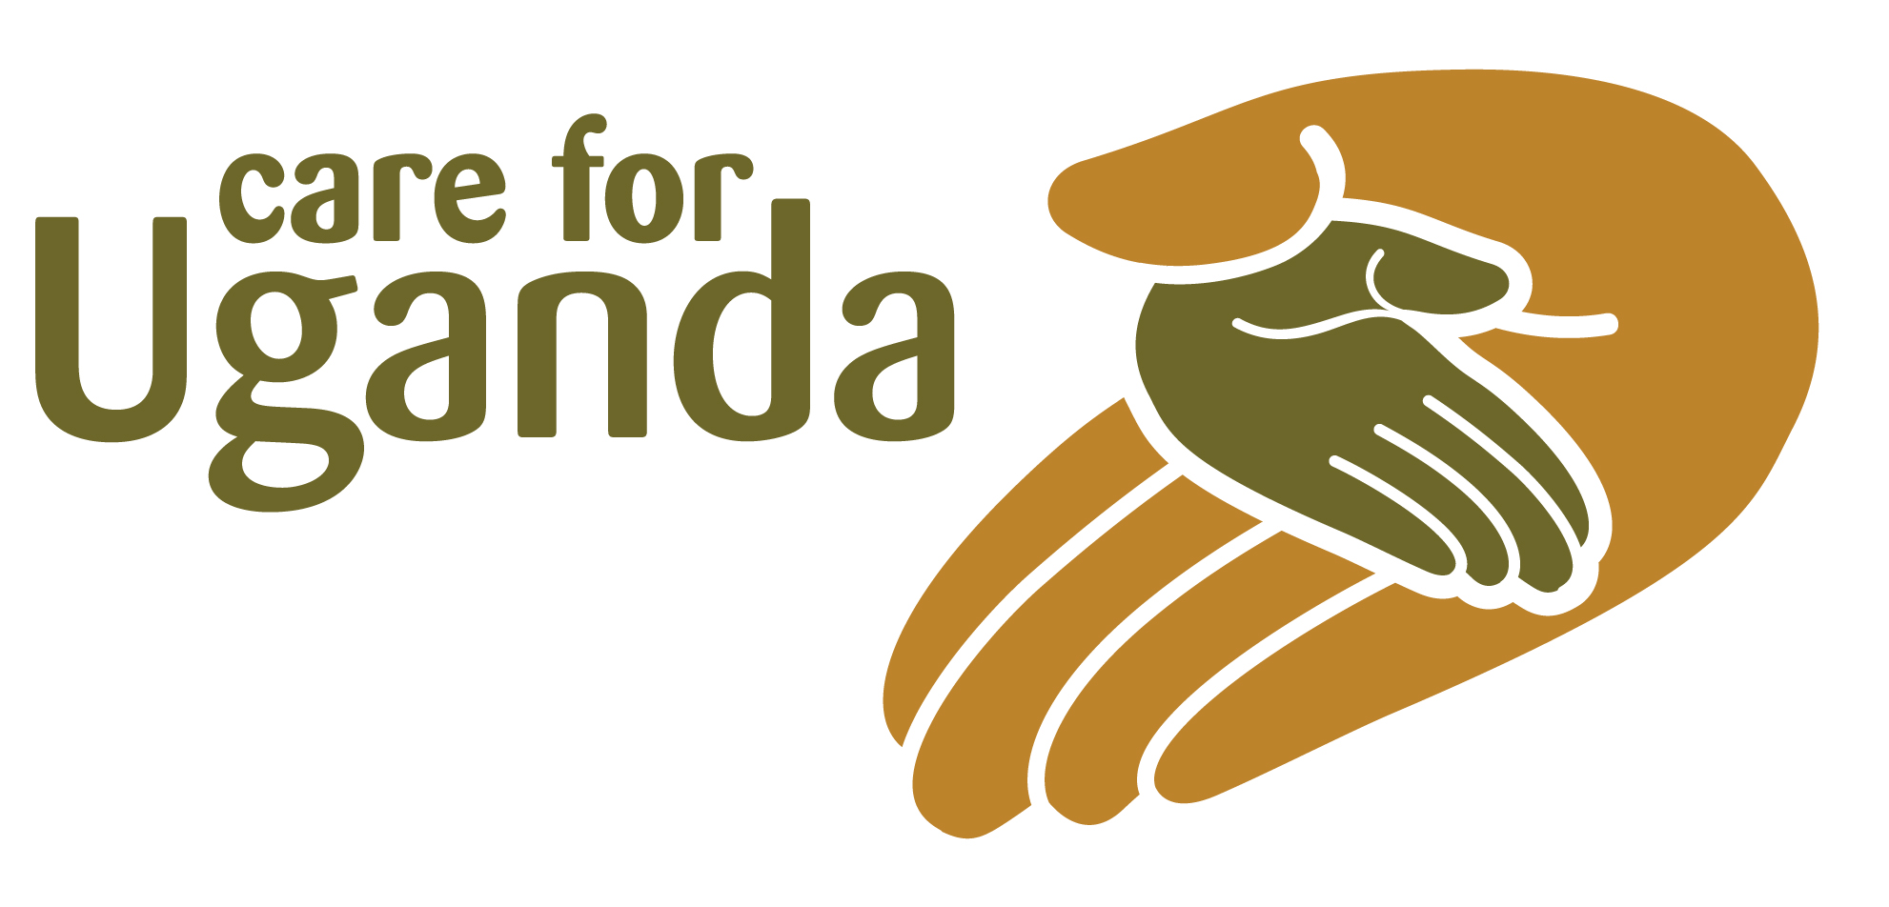

Care for Uganda staff, volunteers, project partners, trustees, grantees and
contractors often work in positions of power both in the UK and oversees. In the UK, there are various legal protections for vulnerable people which are not always present overseas. The UK based work of Care for Uganda is guided by UK law and policies and procedures detailed in the Employee Handbook.
The Code of Conduct below should be followed by all staff, volunteers, project partners, trustees, grantees and contractors when working overseas. They are expected to follow this Code of Conduct regardless of local laws. Where appropriate, grantees and contractors will be expected to sign a copy of the Code of Conduct to signal their commitment to its terms.

Sexual Abuse and Exploitation Code of Conduct
This Code of Conduct outlines expected standards of behaviour of grant recipients (including volunteers and staff), staff, volunteers and trustees, contractors and grant partners (hereafter referred to as staff, grant recipients and partners) towards children (girls and boys), young adults (young women and young men) and community members where work is being done. It has been designed to give all who work with Care for Uganda (staff and partners) the confidence to carry out their roles and ensure that positive relationships are developed and maintained.
Staff, grant recipients and partners have a responsibility to avoid actions or behaviour that may constitute poor practice or potentially abusive behaviour and should ensure that a culture of openness exists wherein actual or potential breaches of the Code may be challenged. Building a positive relationship with the community members you are working with is paramount and it is important that all consider the power dynamics involved in all grant recipient - community relationships and partnerships, not only those involving children.

The Code applies to conduct in work or funded project activity roles, but Care for Uganda expects staff, grant recipients and partners to also apply these good practice principles in their personal lives. Any violation of this policy occurring in relation to staff and others outside their professional roles (i.e. concerns regarding their behaviour towards children or adults that would constitute a breach of the Care for Uganda Terms and Conditions and Code of Conduct) may lead to Care for Uganda considering follow up action, including referral to legal authorities and retraction of grant.
All Care for Uganda staff, grant recipients and partners are prohibited from engaging in the following harmful behaviour, including but not limited to:
- Any behaviour or activity that could amount to sexual exploitation and abuse
- Sexual activity with children (persons under the age of 18) regardless of the age of majority or age of consent locally. Mistaken belief regarding the age of a child is not a defence.
- Exchange of money, employment, goods, or services for sex, including sexual favours or other forms of humiliating, degrading or exploitative behaviour.
- Any other activity that is intended to cause physical or emotional harm, humiliation or exploitation to any individual.
- Any activity, practice or behaviour that suggests staff, grant recipients or partners have abused their position of power and is engaging any individual based on inherently unequal power dynamics.
- Sexual relationships between staff-, grant recipients-, partners and any individuals that are based on unequal power dynamics are strongly discouraged since they may undermine the credibility and integrity of the work of Care for Uganda.

In addition, staff, grant recipients and partners must:
- Create and maintain an environment that prevents all forms of exploitation and abuse and promotes the implementation of this Code of Conduct. Grant recipients have particular responsibilities to support and develop systems that maintain this environment.
- Report any concern or suspicion of exploitation, including sexual exploitation, abuse or breach of the Code of Conduct by a fellow member of staff immediately via the established reporting mechanisms (focal point)
- Make sure you know how to contact your focal point if you need to manage disclosures of abuse.
- In the event of a violation or suspected breach of the Code of Conduct, please contact Andrew Pilcher, CEO, Care for Uganda as soon as possible to discuss next steps.

I ____________________________ from _________________________ understand and agree to abide by the above principles and Code of Conduct. I understand that any breaches of the above Code will be responded to in accordance with the policies and procedures in place.

Signature: ____________________________ Date________________________

